Title: Understanding Hashing: The Key to Data Integrity and Security



In the world of cybersecurity and data management, hashing plays a pivotal role in ensuring data integrity, authentication, and encryption. This article explores the concept of hashing, the generation of hash values, the algorithms used for hashing, and the key distinctions between hashing and encryption.

**What is Hashing?**

Hashing is a fundamental process in computer science and cryptography that transforms input data (often called a message) into a fixed-size string of characters, known as a hash value or simply a hash. The purpose of hashing is to create a unique representation of data, making it efficient to compare and verify large datasets.

**Hash Values and Their Properties**



A hash value is a string of characters generated by applying a hash function to the input data. Some key properties of hash values include:

1**. Fixed Length**: Regardless of the size of the input data, a hash function produces a hash value of a fixed length.

2. **Deterministic**: The same input data will always produce the same hash value when processed by the same hash function.

3. **Fast Computation**: Hash functions are designed to generate hash values quickly, making them suitable for various applications.

4. **Avalanche Effect**: A small change in the input data should result in a substantially different hash value.

5. **Preimage Resistance**: Given a hash value, it should be computationally infeasible to reverse-engineer the original input data.

**Common Hashing Algorithms**

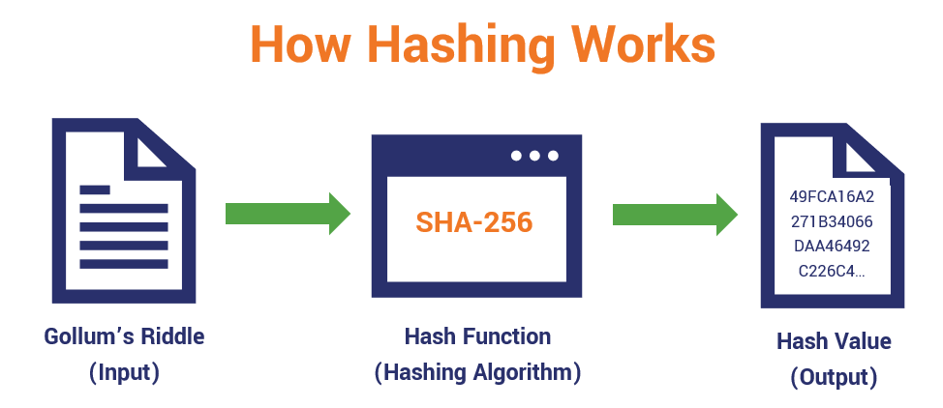

Several hashing algorithms are widely used in the field of cybersecurity and data management. Some notable examples include:

1. **MD5 (Message Digest 5**): Despite its past popularity, MD5 is considered weak today due to vulnerabilities that allow for collisions (different inputs producing the same hash).

2. **SHA-1 (Secure Hash Algorithm 1):** Similar to MD5, SHA-1 is now considered outdated and vulnerable to collision attacks.

3. **SHA-256 and SHA-3**: Part of the Secure Hash Algorithm family, these are more secure and resistant to collisions.

4**. bcrypt and Argon2**: These are specifically designed for password hashing, making it difficult for attackers to crack hashed passwords.

**Hashing vs. Encryption**

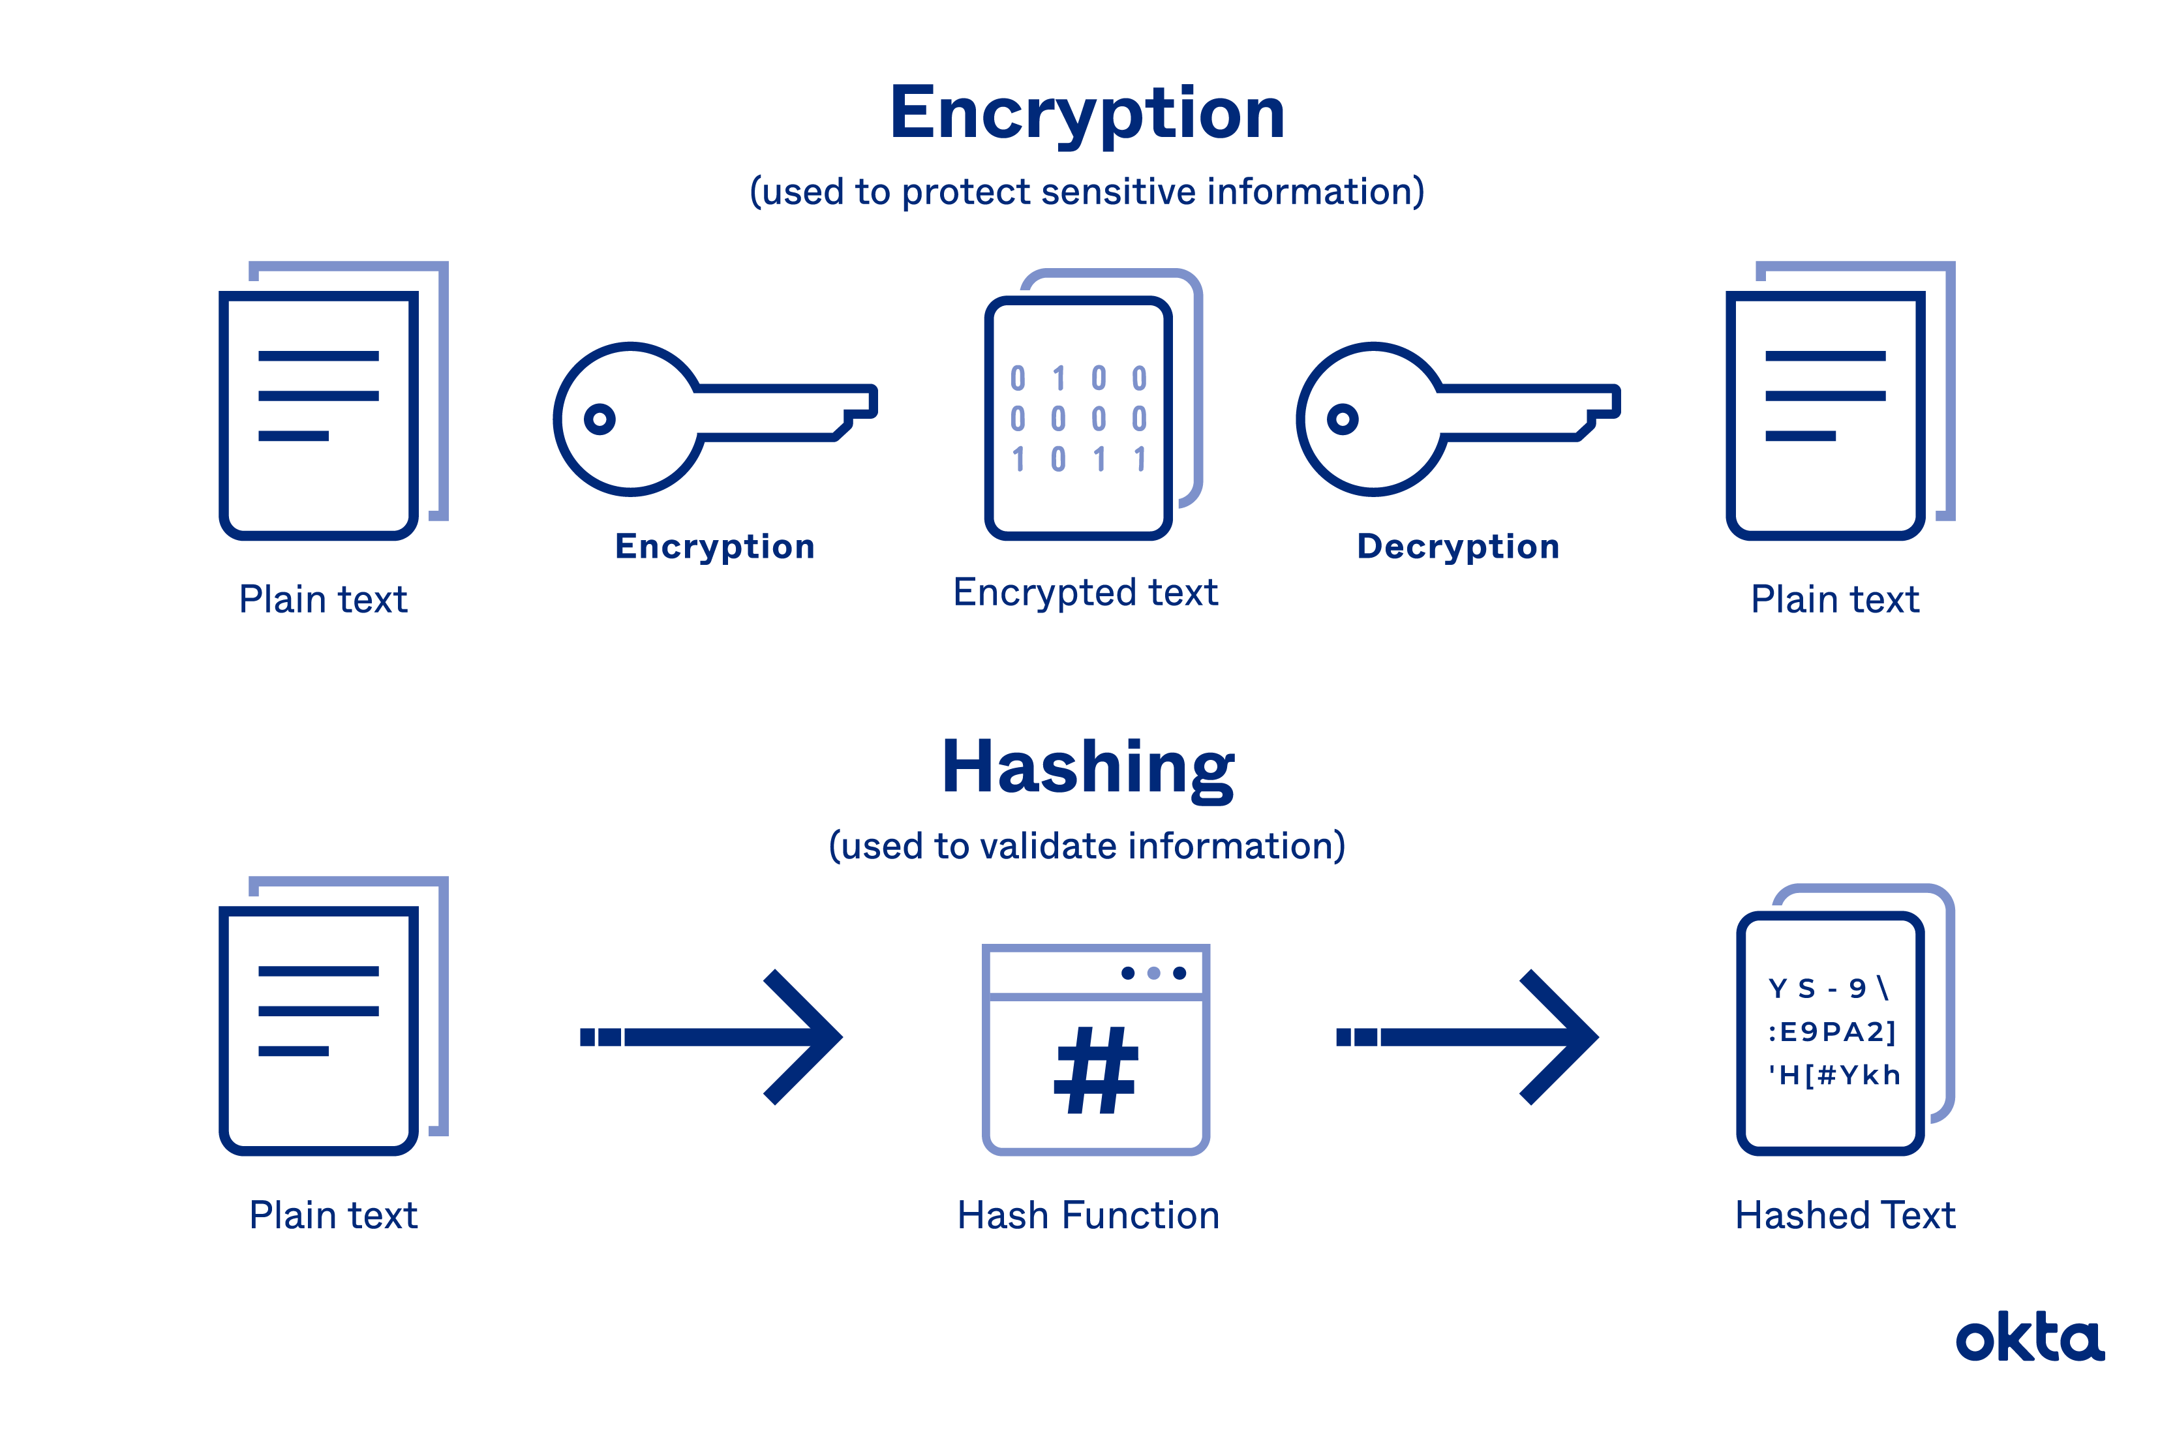

While both hashing and encryption are cryptographic techniques, they serve distinct purposes and exhibit key differences:

1. **Purpose:**

- Hashing: Designed for data integrity verification and indexing, ensuring the integrity of data during storage and transmission.

- Encryption: Focuses on data confidentiality, ensuring that unauthorized parties cannot read the original data.

2. **Reversibility:**

- Hashing: Irreversible process; hash values cannot be transformed back into the original data (preimage resistance).

- Encryption: Reversible process; encrypted data can be decrypted using the appropriate key.

3. **Fixed Length:**

- Hashing: Produces hash values of a fixed length.

- Encryption: Typically, does not enforce a fixed output length.

4. **Usage:**

- Hashing: Commonly used for data verification, indexing, and password storage.

- Encryption: Utilized for securing data at rest or in transit, ensuring confidentiality.

In conclusion, hashing is a critical component of cybersecurity and data management, serving to verify data integrity and provide a unique identifier for data sets. Understanding the key distinctions between hashing and encryption is essential for using these techniques effectively in various applications, ultimately safeguarding data and information in our digital world.